Conflict of Interest Disclosure Form
(to be completed by scientific/organising committee members/faculty members)

NAME : Rudolph W. Koster MD, PhD

AFFILIATION: Academic Medical Center, Amsterdam, Netherlands
In accordance with criterion 14 of document UEMS 2016/20 “EACCME® criteria for the Accreditation of Live Educational Events (LEEs)”, all declarations of potential or actual conflicts of interest, whether due to a financial or other relationship, must be provided to the EACCME® upon submission of the application. Declarations also must be made readily available, either in printed form, with the programme of the LEE, or on the website of the organiser of the LEE. Declarations must include whether any fee, honorarium or arrangement for re-imbursement of expenses in relation to the LEE has been provided.

DISCLOSURE
I have no potential conflict of interest to report*

I have the following potential conflict(s) of interest to report*
X
* Please type X in the appropriate box.
Type of affiliation / financial interest | Name of commercial company
Receipt of grants/research supports:  -For the Safety study: Devices on loan, consumables and financial support  -For the AED text message study: Financial support | Zoll Medical, Jolife, now part of Physio-Control, now part of Stryker  Netherlands Heart Foundation, Netherlands Orghanization for Medical Research, AED manufacturers Physio Control, Zoll Medical, Philips Netherlands, Cardiac Science, Defibtech
Receipt of honoraria or consultation fees:
Participation in a company sponsored speaker’s bureau:
Stock shareholder:
Spouse/partner:
Other support (please specify):
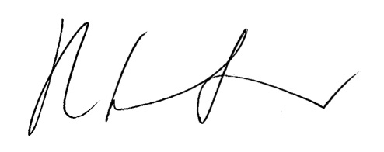
R.W. Koster Date: April 13, 2018

